Lab 1: Introduction to Digital Forensics – Autopsy software
What You Need for this lab
- Windows 10
- Investigate a USB drive
  - Owned by George Montgomery
- Assume we have the image file
  - https://www.dropbox.com/s/nw23q14vzsykyup/Ch01InChap01.dd
  - (from book Guide to Computer Forensics and Investigations. Sixth Edition)
- Software
  - Autopsy : https://www.autopsy.com/download/
- Tasks
  - Recover Word files, images
  - Search key words
Step 1.
Check hash code online : https://emn178.github.io/online-tools/md5_checksum.html
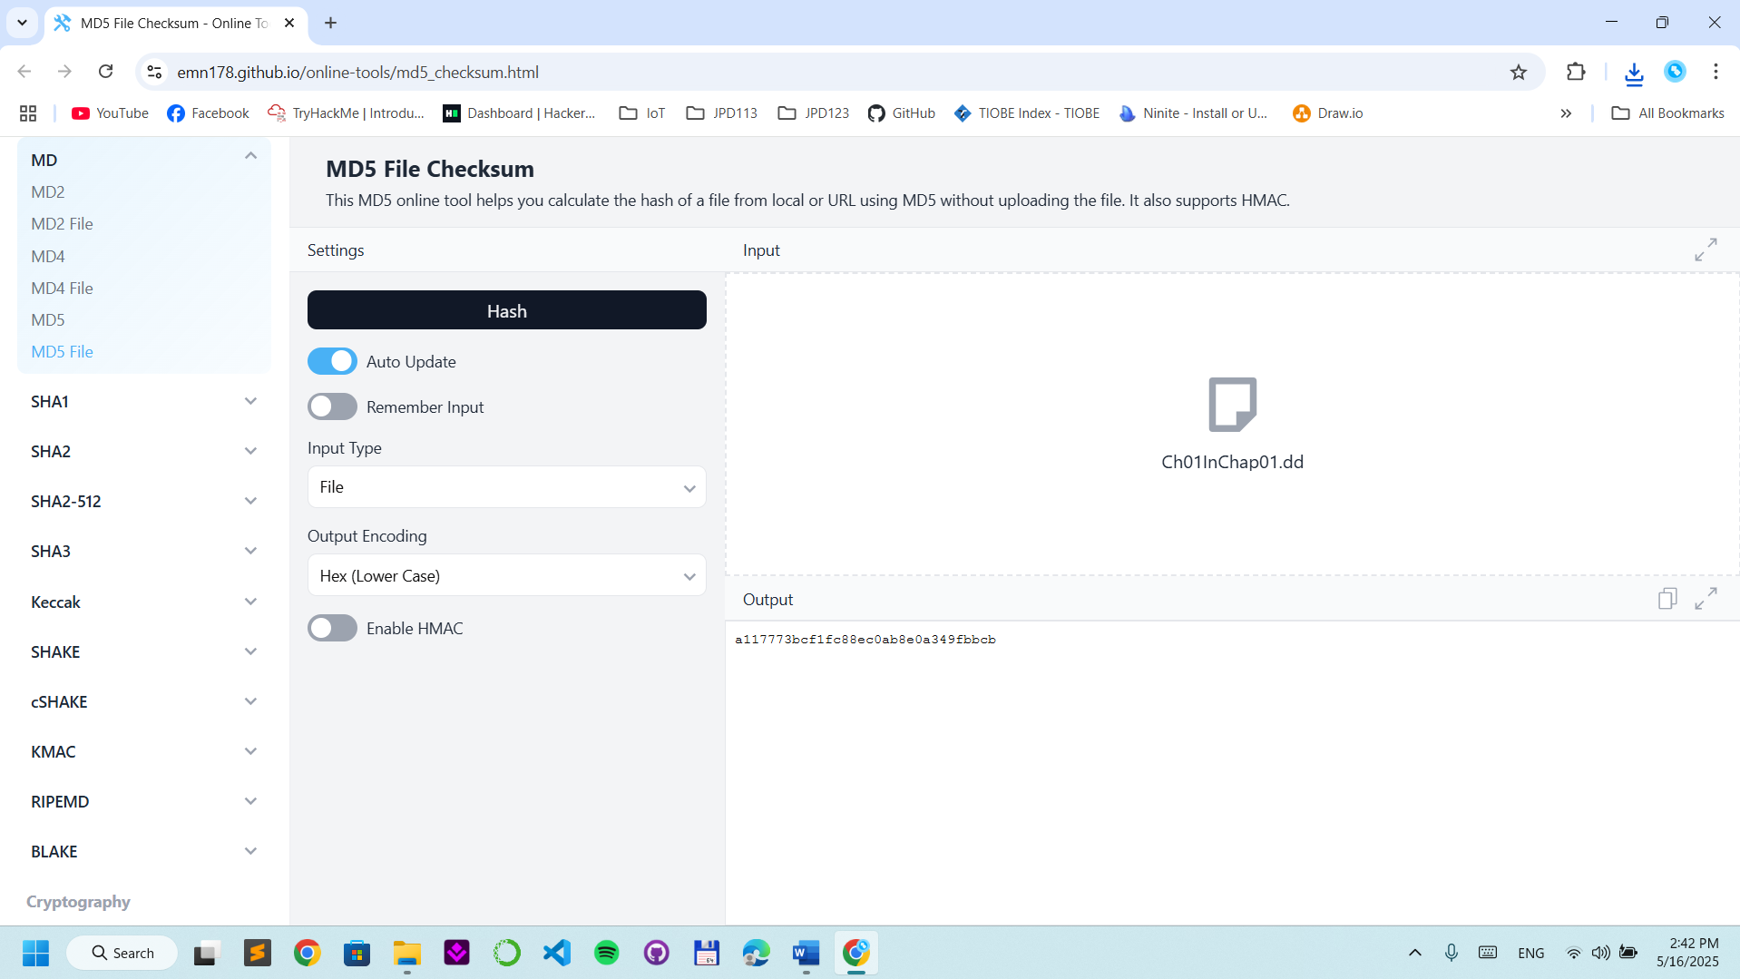
Step 2.
Create a case with name
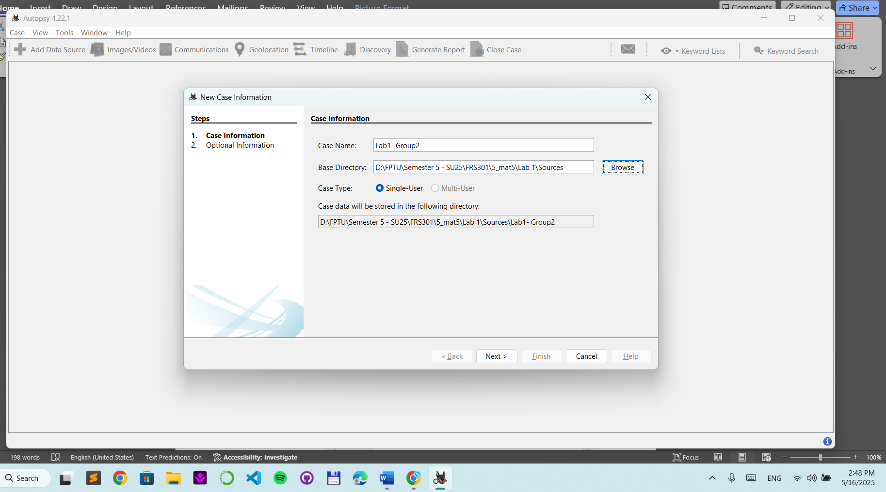
Details of the case
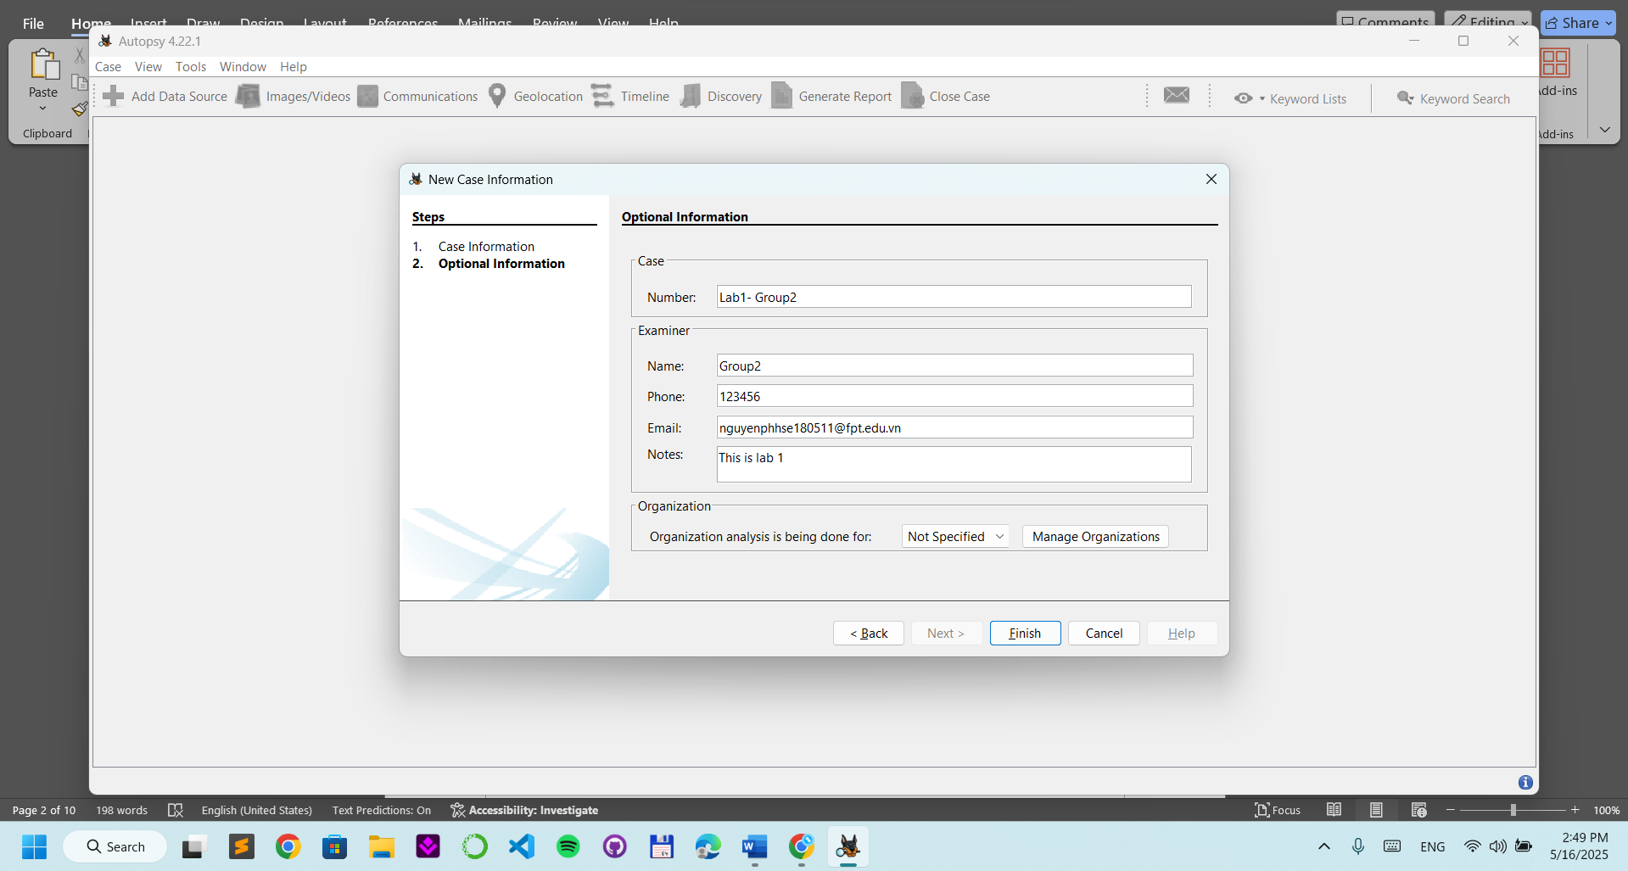

Choose Data Format
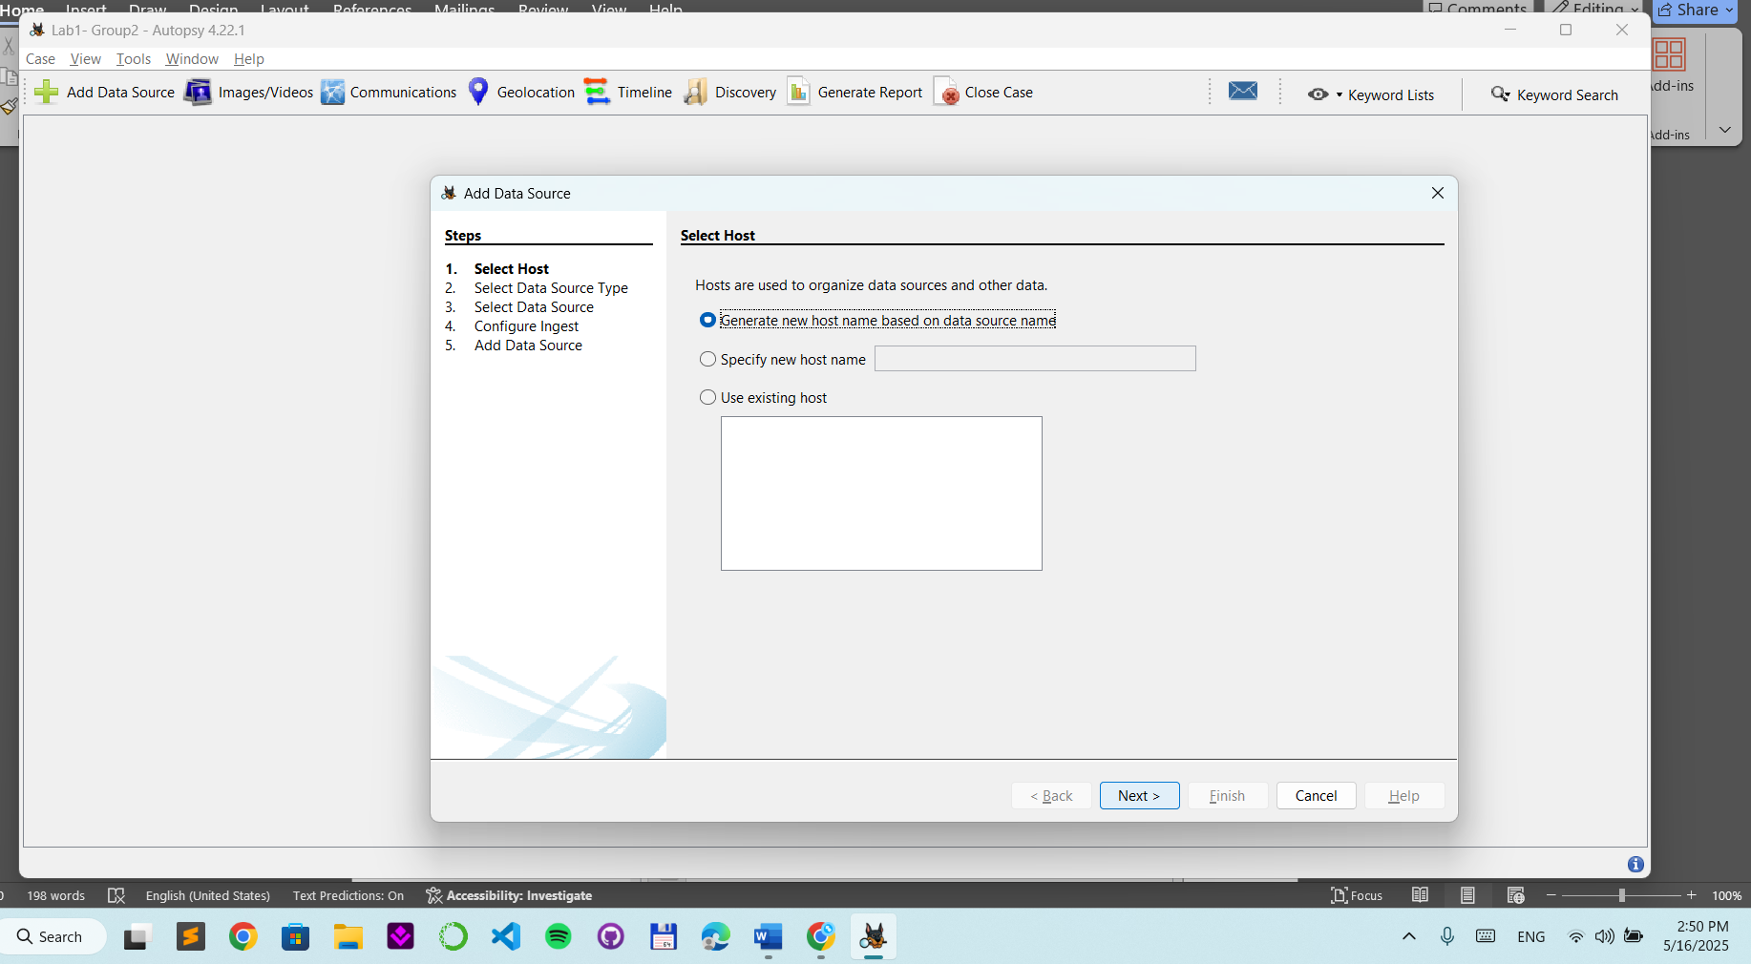
Click Disk Image or VM File
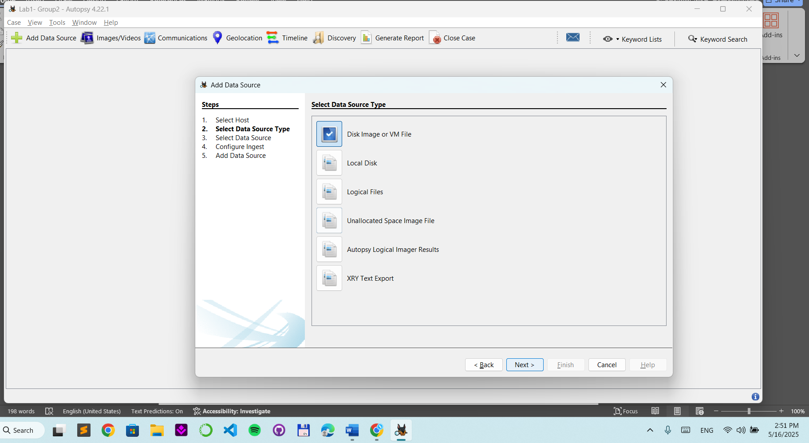
Choose the image file
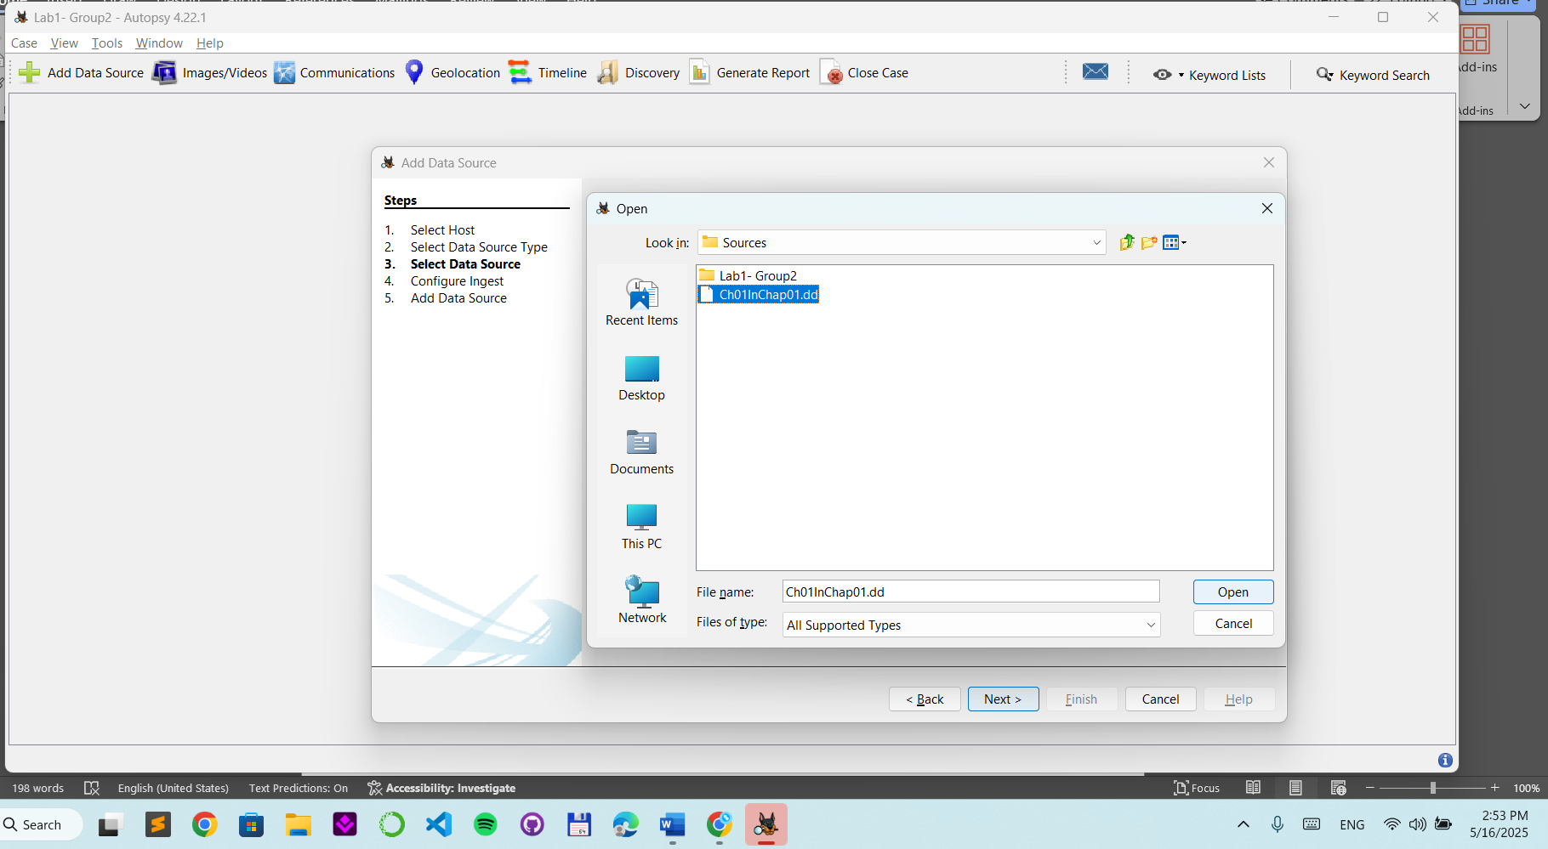

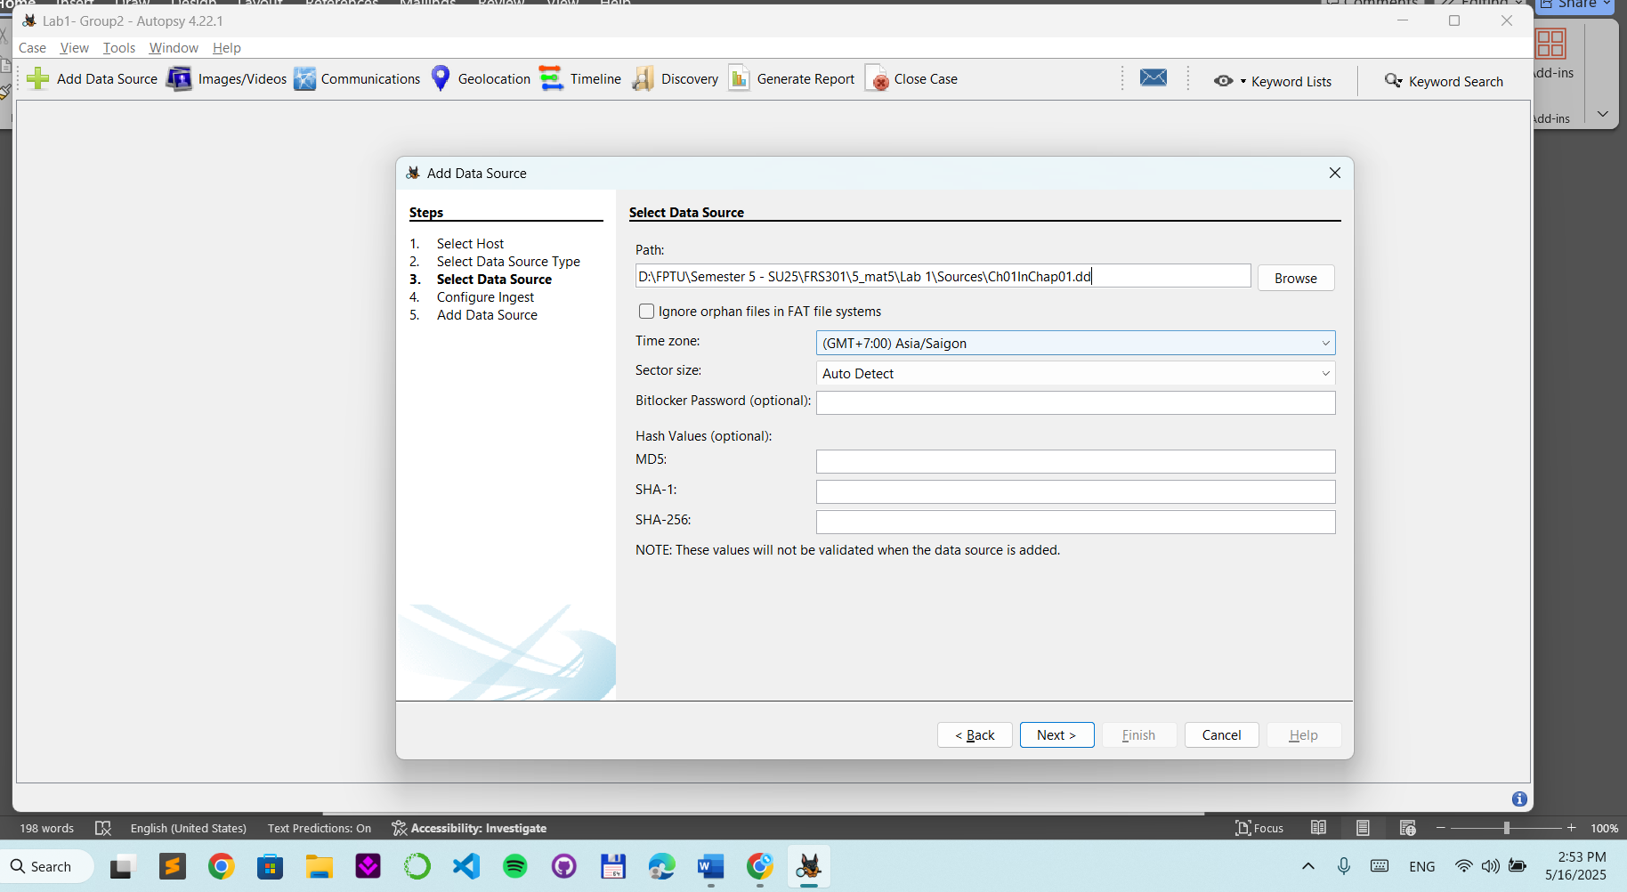

Find deleted files :
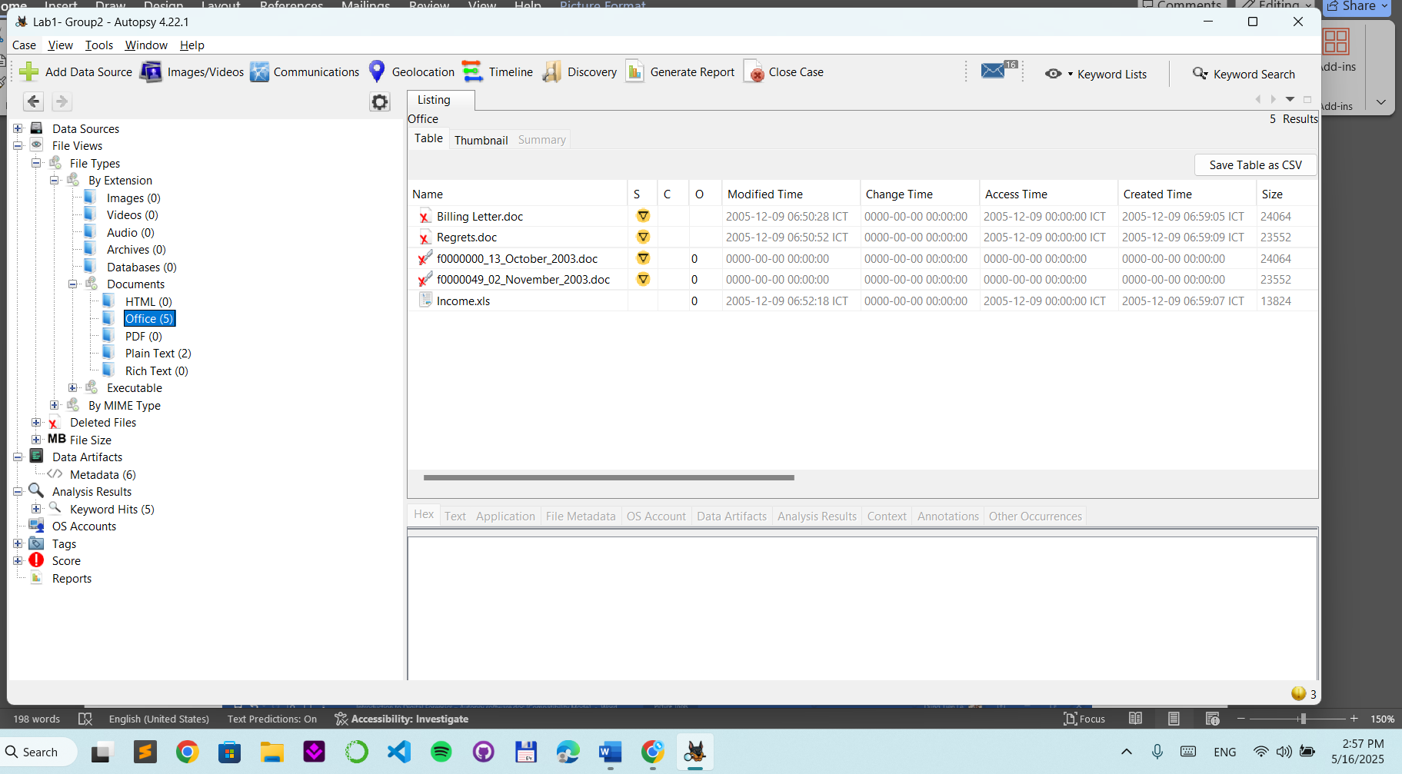
Tag the file: right click and click New Tag
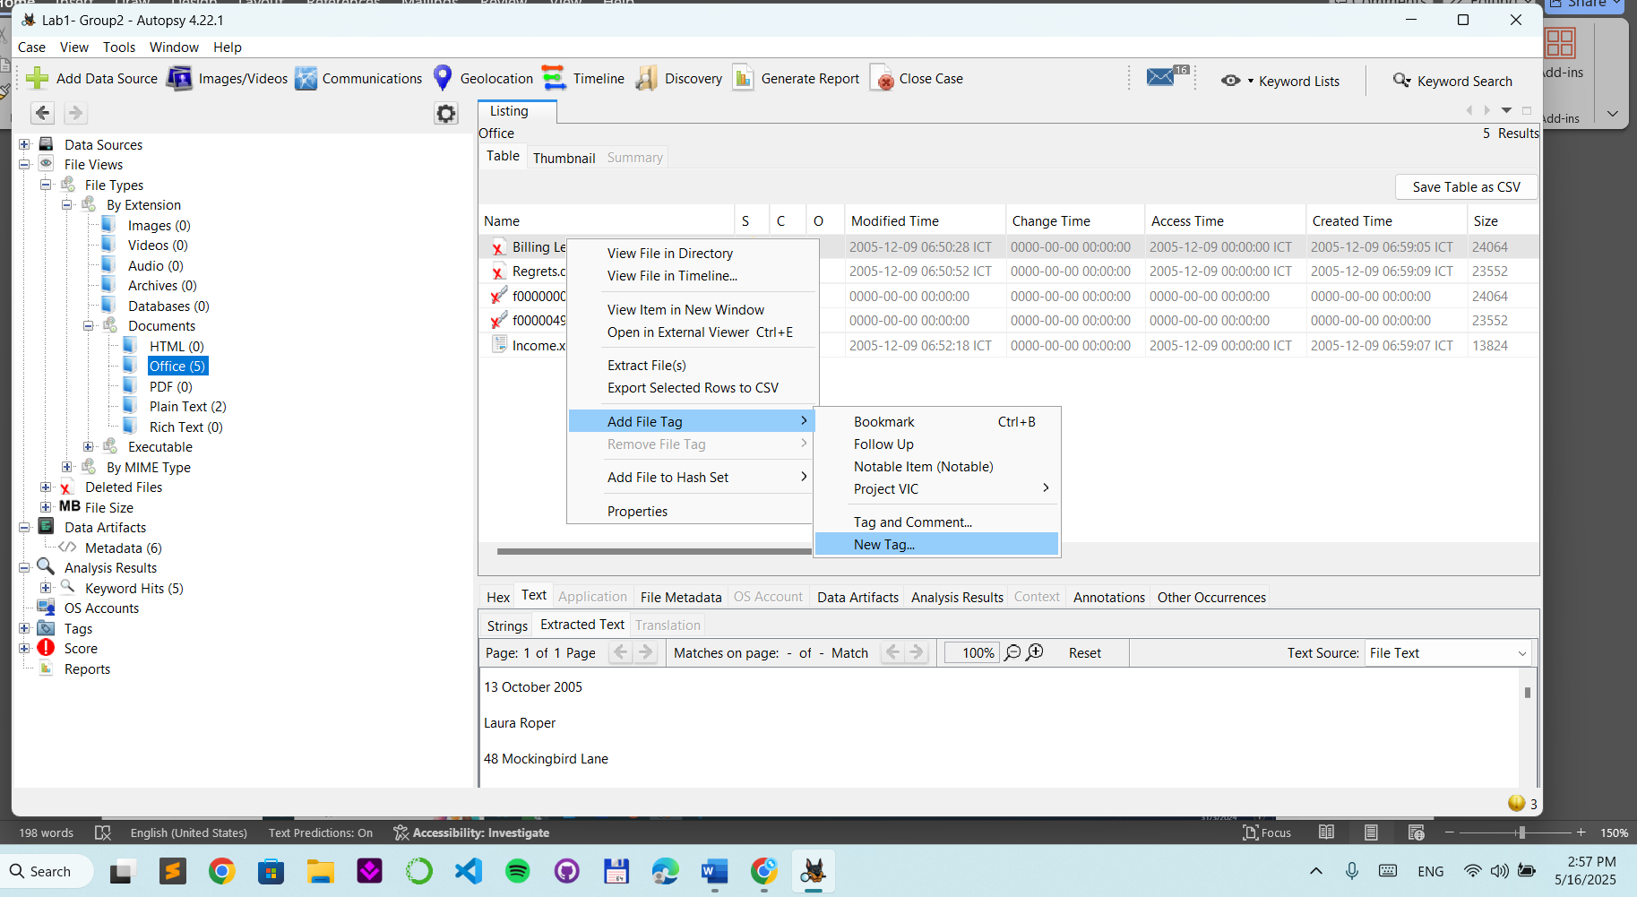

Step 3.
Create a tag for reporting
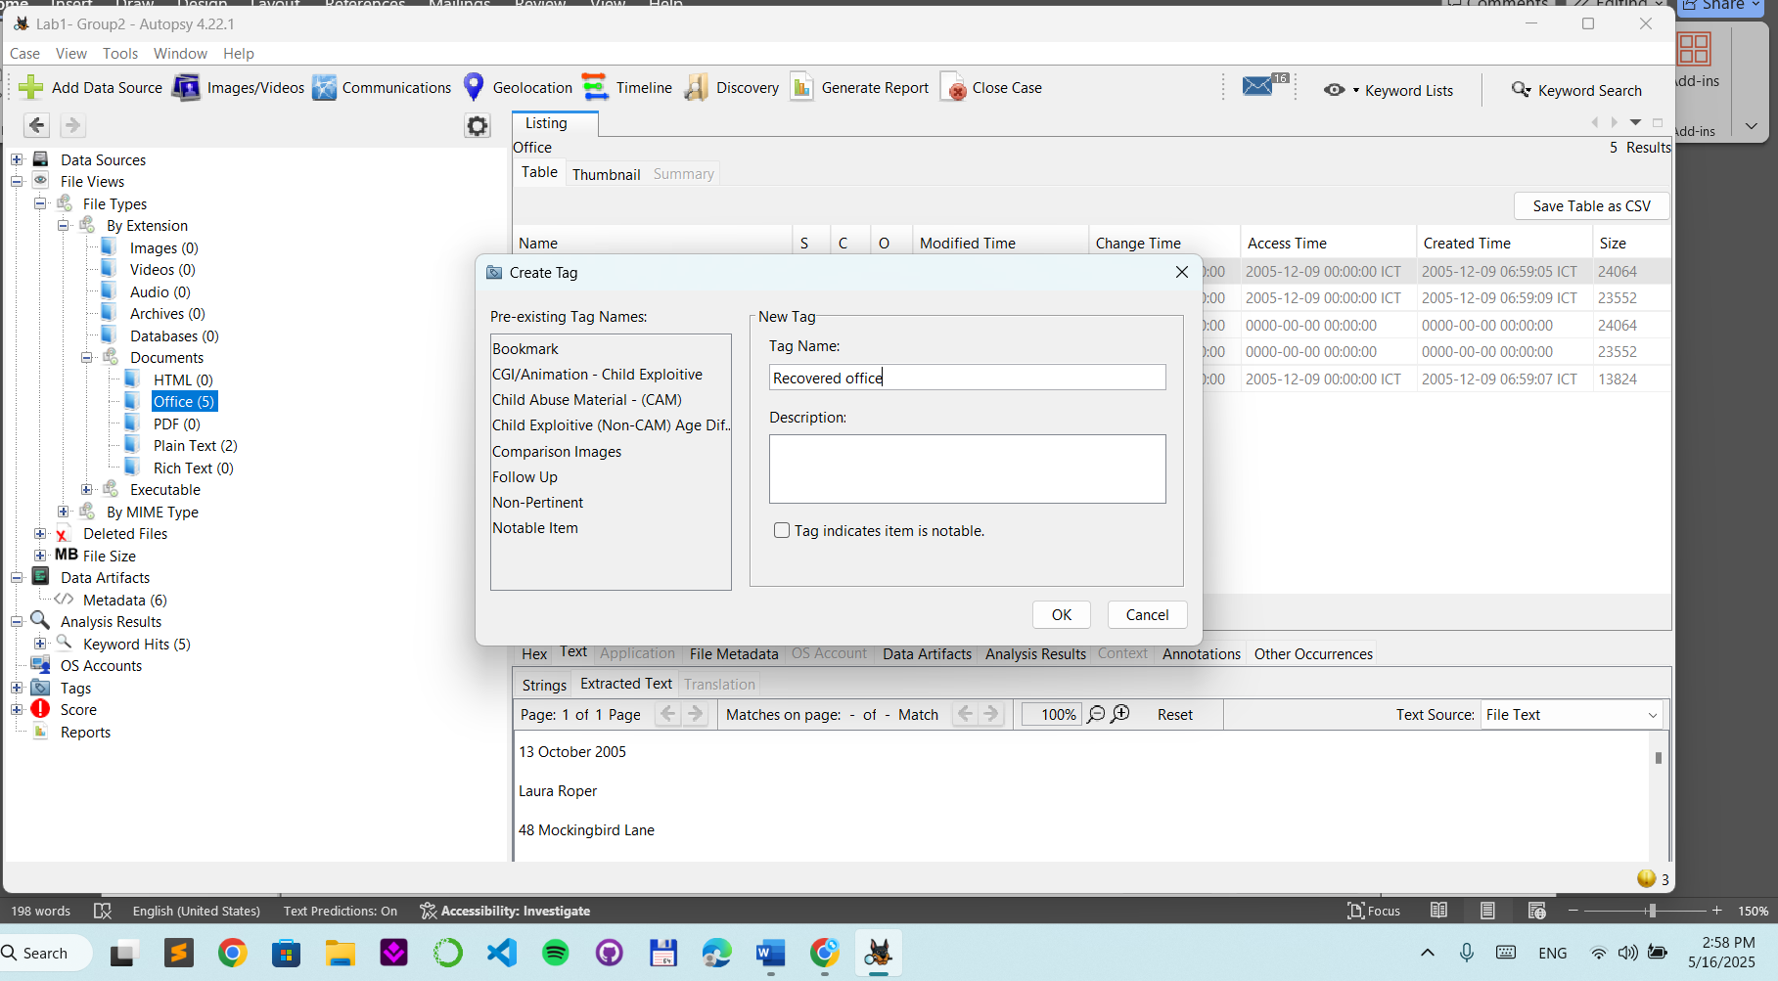
Tag both deleted files
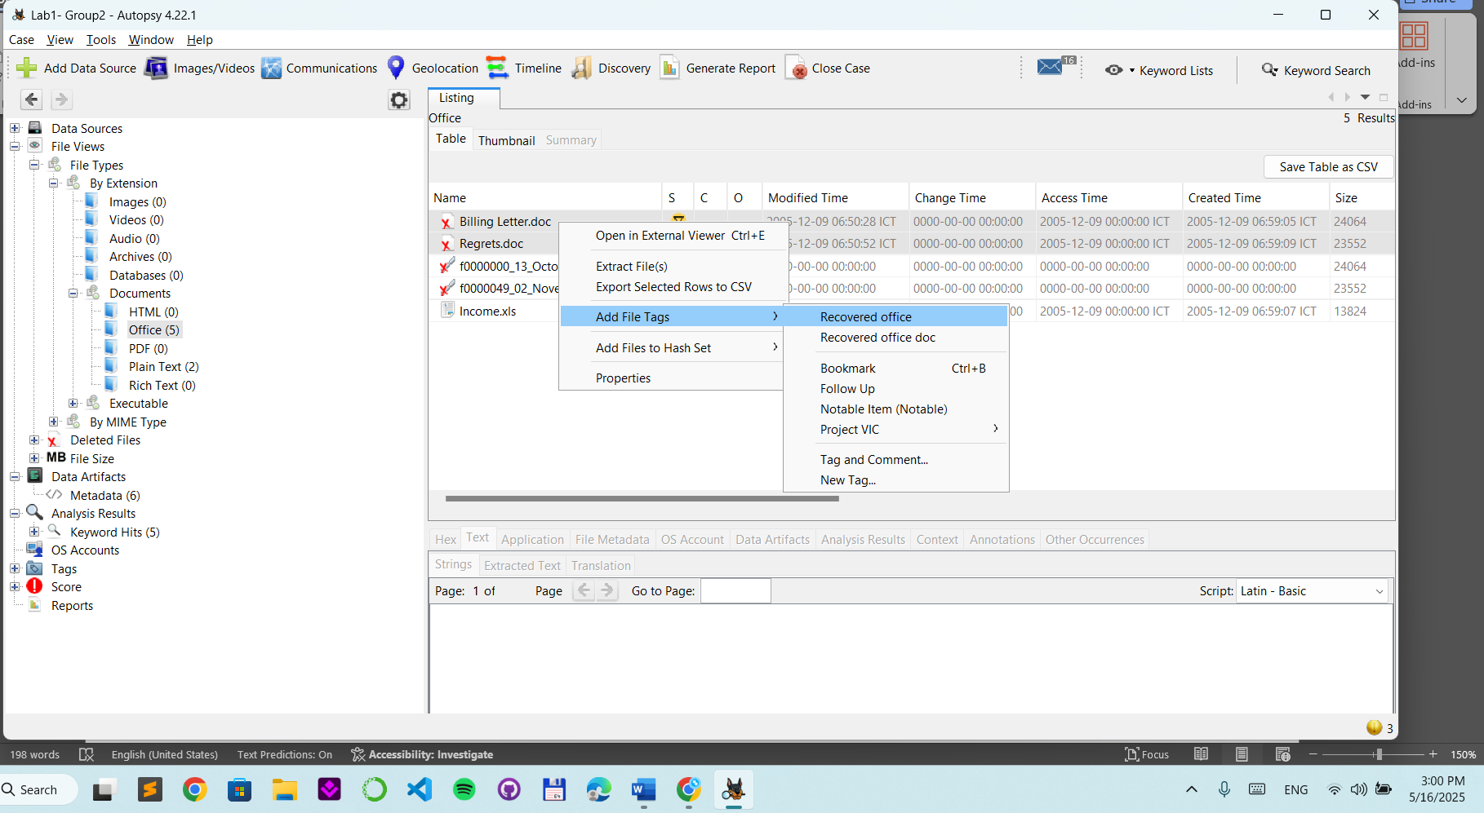

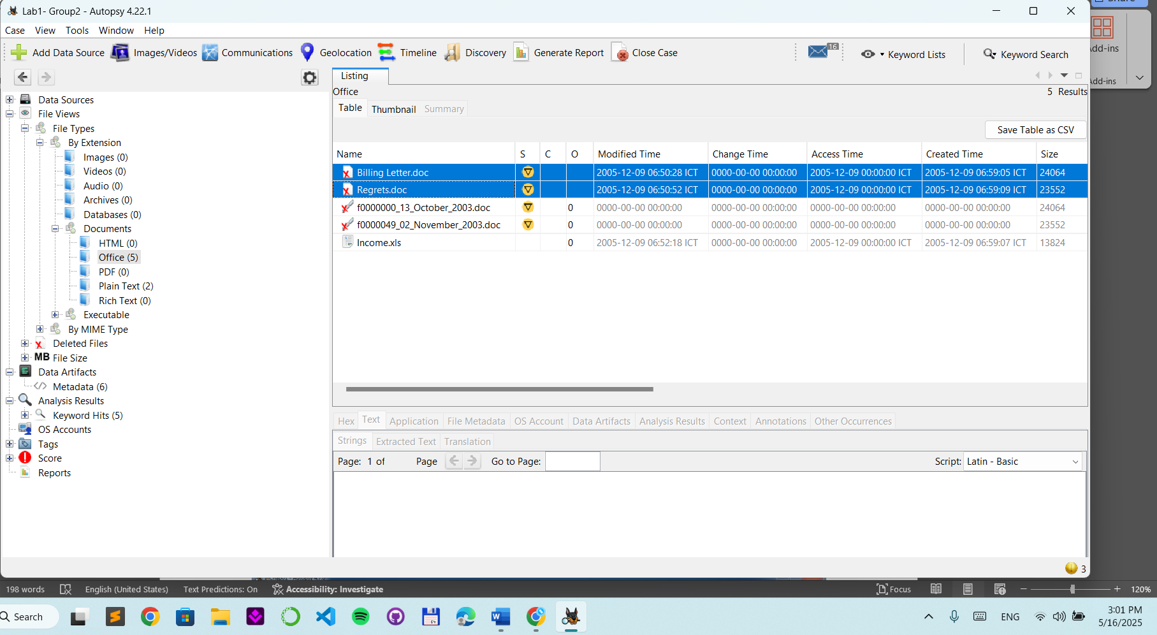

Step 4.
Recover deleted file
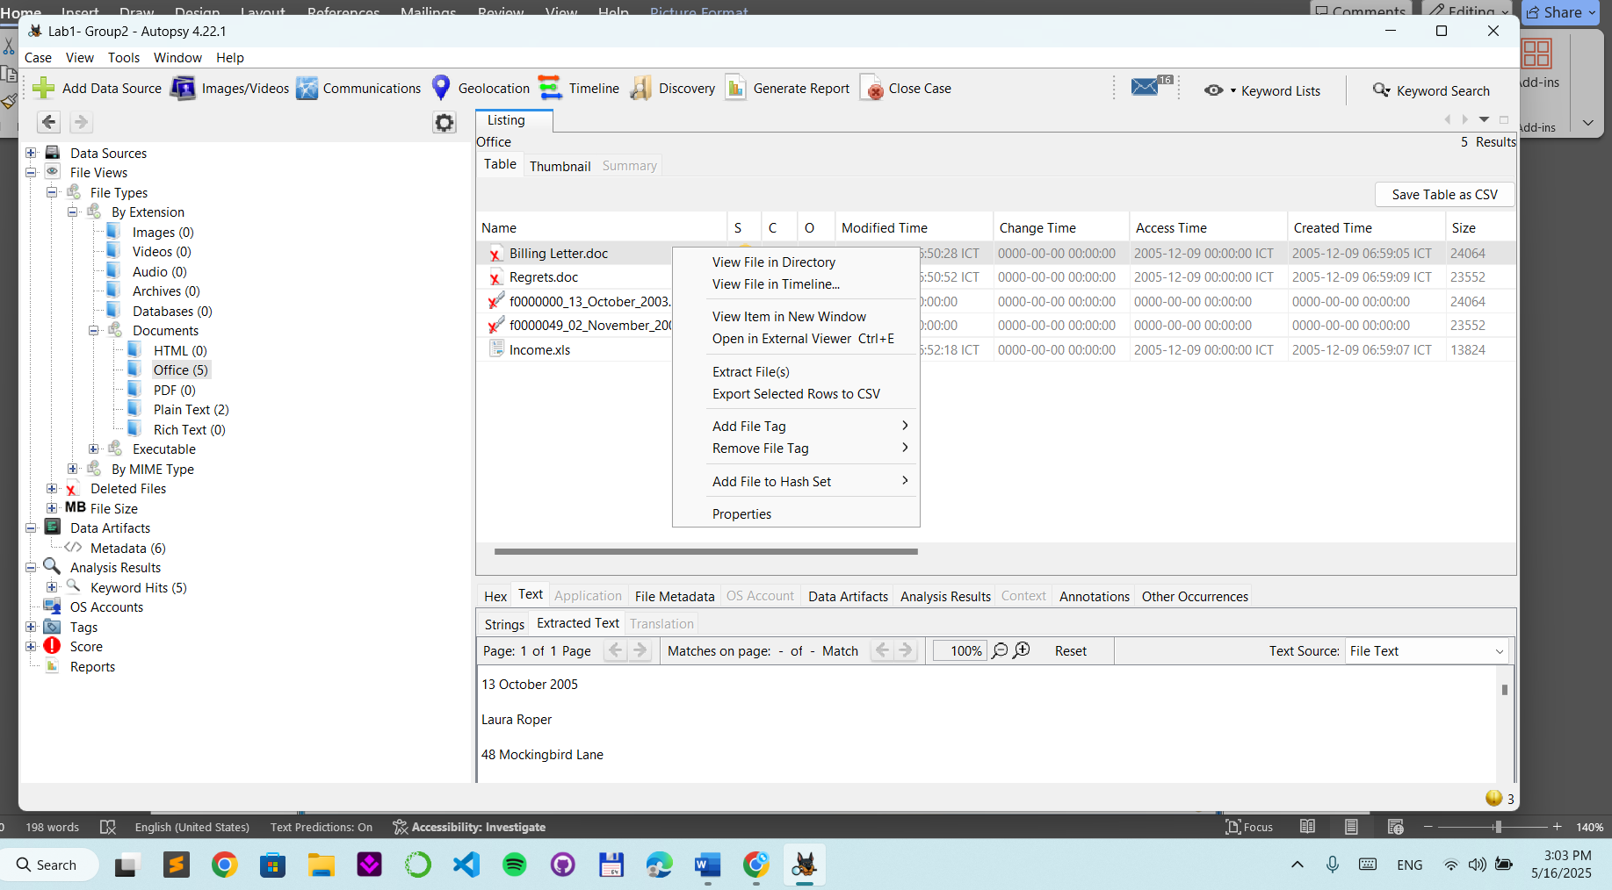
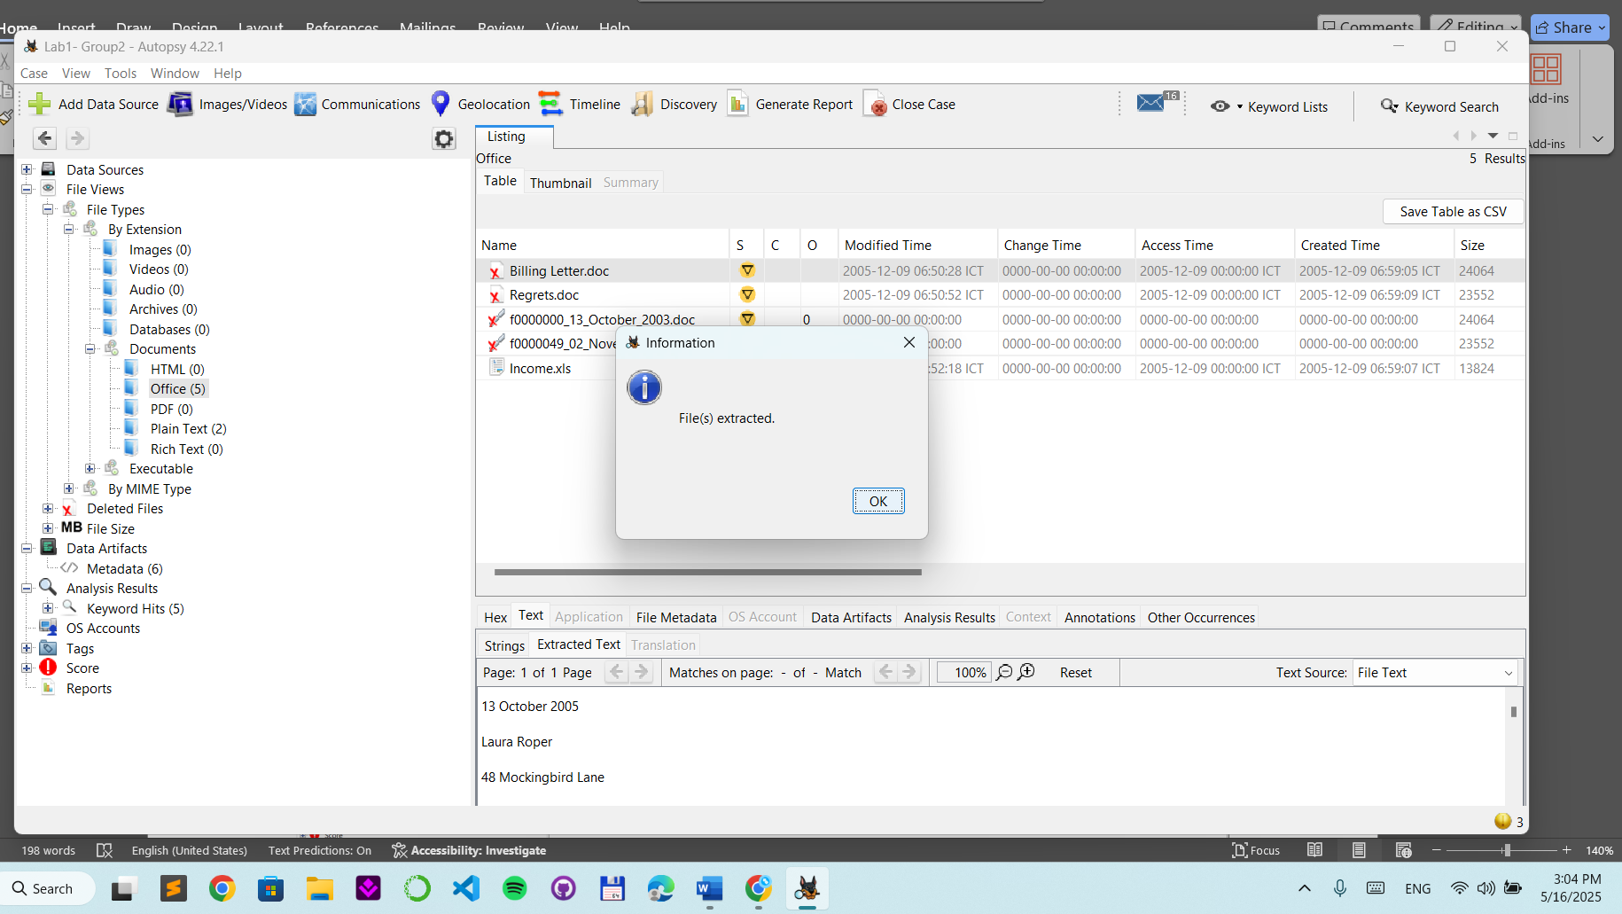
Search keywords : “George”
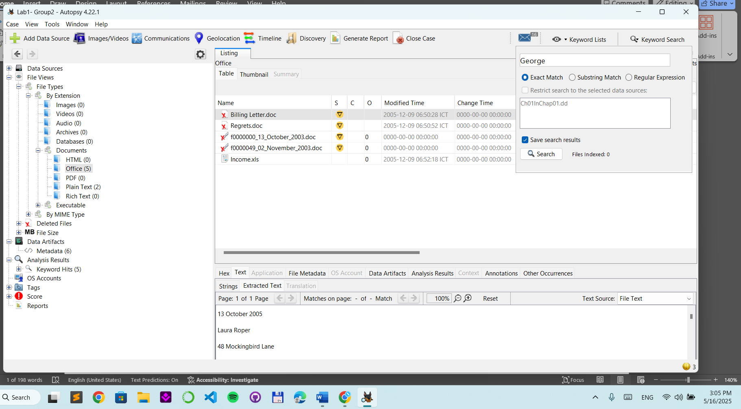

Search results
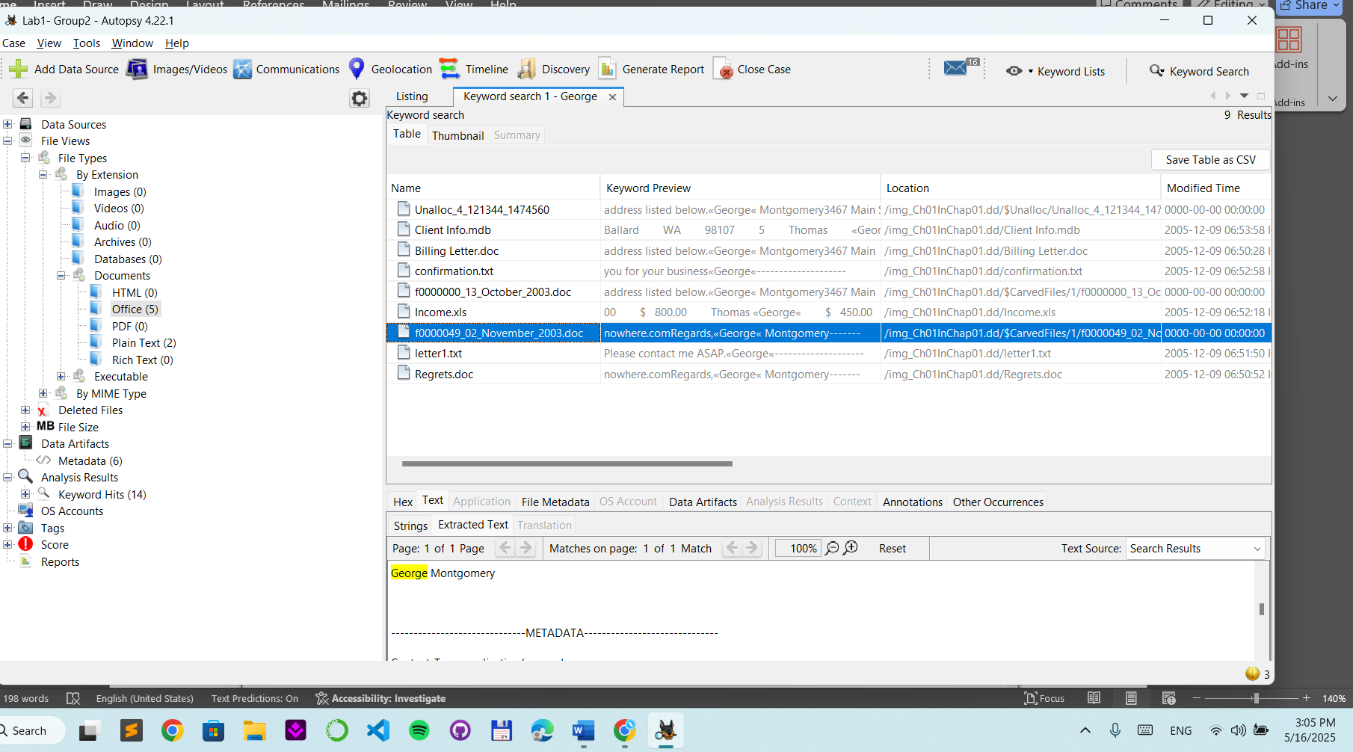
Step 5.
Generate reports
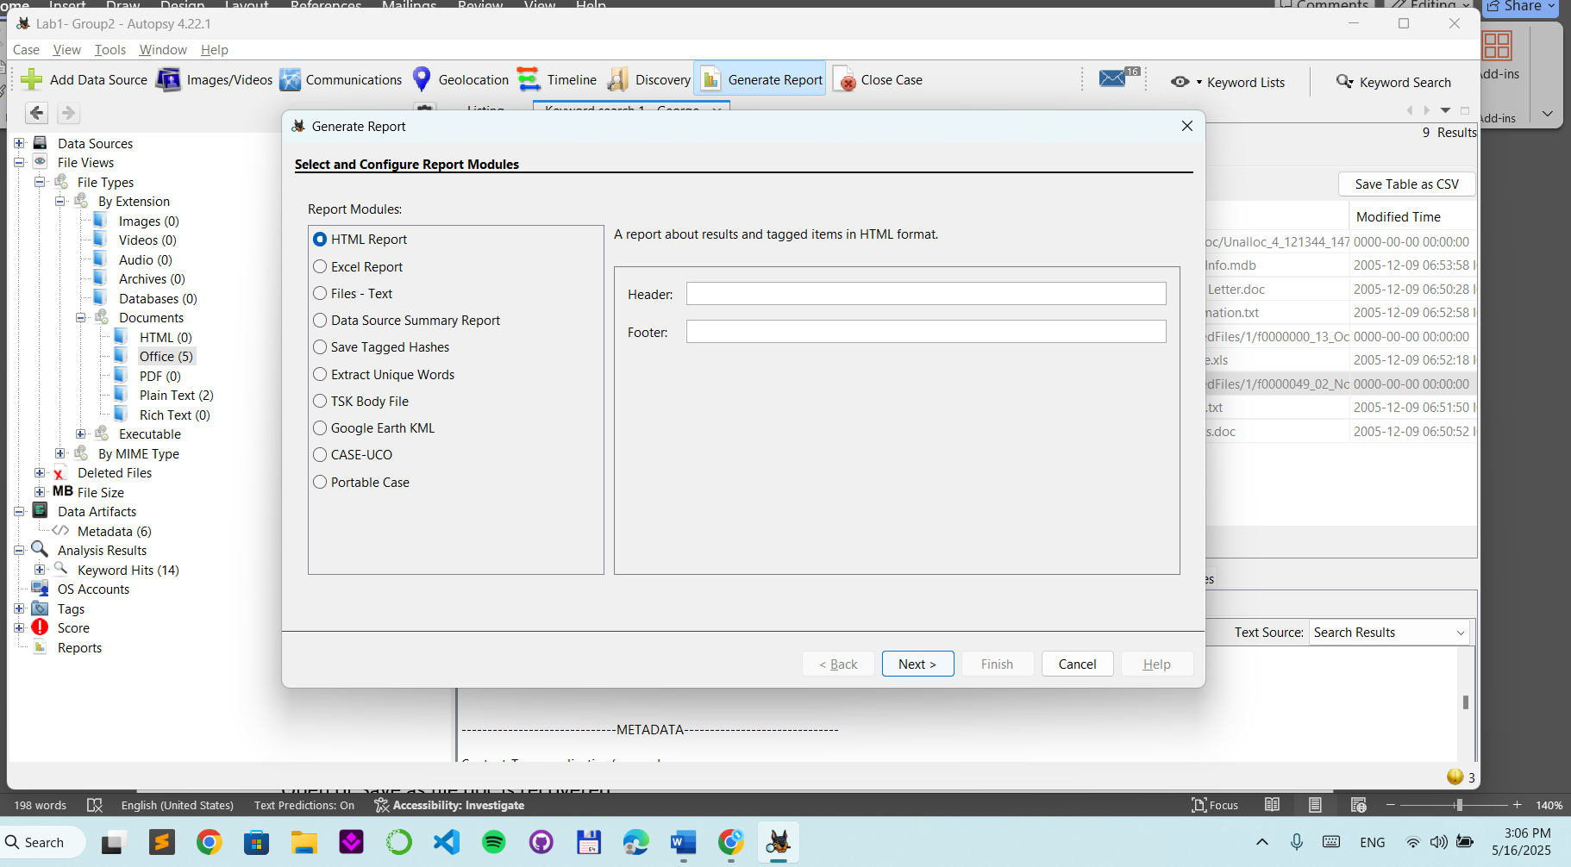
Open or Save as file doc is recovered.
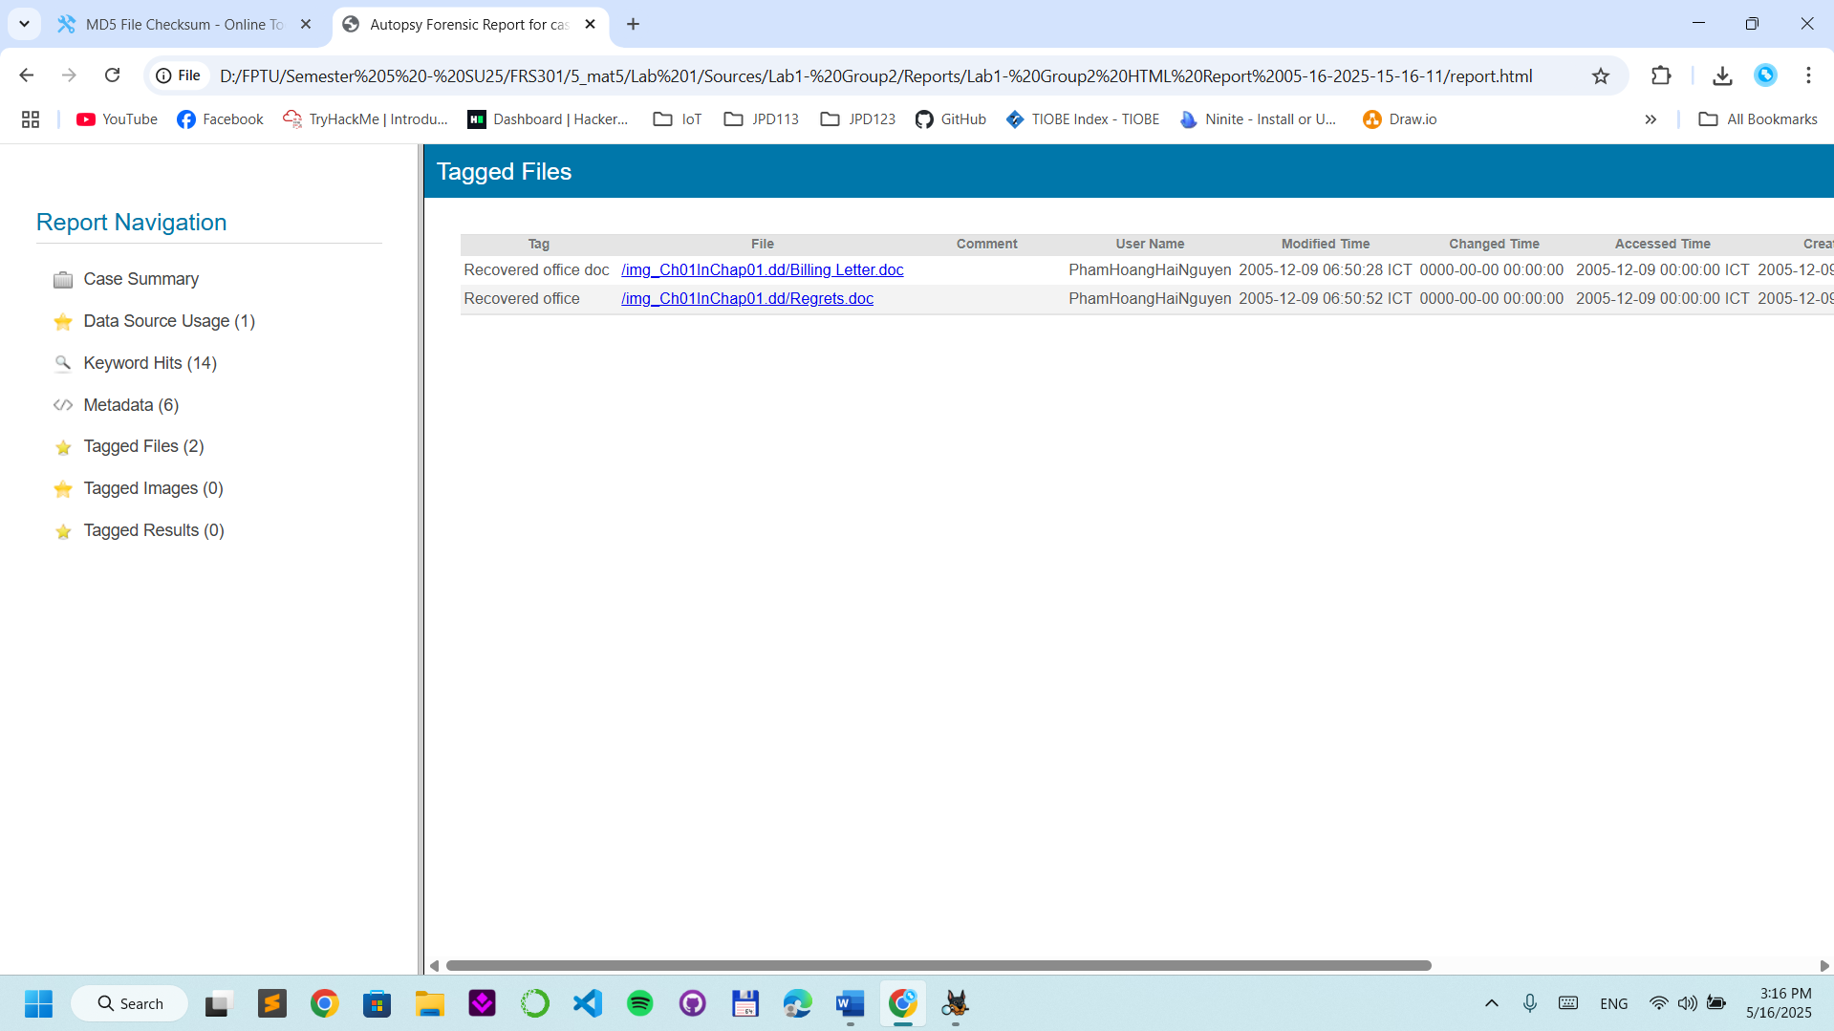

YOU MUST SUBMIT A FULL-SCREEN IMAGE FOR FULL CREDIT!
Save the document with the filename "YOUR NAME Lab 1.pdf", replacing "YOUR NAME" with your real name.
Email the image to the instructor as an attachment to an e-mail message. Send it to: xxx@fe.edu.vn with a subject line of "Lab 1 From YOUR NAME", replacing "YOUR NAME" with your real name.

